




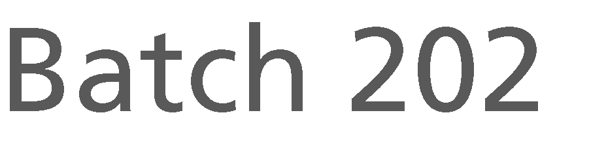


Document Version / Details Ver. 6/ 08-September-2025



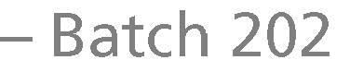







Eligibility Criteria for T School Hiring – 2026 Batch
Qualification | 2026 Batch of B.E/ BTech/ ME/ MTech (all branches of engineering) /MCA/ M.Sc.- 5 Yrs integrated CS & IT branches only (all education in full-time/regular courses)
Branches | All Branches of Engineering
Academic Gap | Not more than 2 years academic gap allowed. (SSC/HSC/Diploma/UG/PG)
SSC, HSC Percentages, Diploma (if applicable), Graduation Percentage/CGPA | Consistent academic records of 60% in 10th, 12th, Diploma (as applicable), UG and PG courses (aggregate of all semesters & subjects)  NOTE:  - Appropriate CGPA to percentage conversion to be considered as per the respective university norms. The scores of the Main or improvement exam would be considered as final.  - For candidates who have pursued both HSC and Diploma, marks scored in the Diploma course will be considered.
Re-attempts/ATKTs  /Backlogs/Arrears (Diploma, Graduation) | - Initial results (% scores) declared would be considered for students awaiting re-evaluation results.  - At the time of recruitment process, there must be no standing arrears in current education
Nature of Course | All Full-Time Courses Only
Year of Passing | 2026 Pass Outs Only
Citizenship | Should be an Indian National
Your College/Institution MUST  be | UGC / AICTE / State Board Approved ONLY
Pre-Employment Verification | Not been involved in any court proceedings and/or convicted for any offence
Self-Declaration:

- hereby declare that I meet ALL the eligibility criteria exactly as stated above.
- I am aware that I may be subjected to immediate action by the company at any time during or after the Interview/Selection/Joining if found hiding any information/producing incorrect information or not meeting all the criteria mentioned above.
- As a future IT professional, I am flexible towards working from any of LTIMindtree’s development centers
across the country, flexible work durations/time, training and working in multiple emerging skills & domain.
- I confirm that I have NOT appeared for any LTIMindtree interview process anywhere in the past 6 months. (If found so, LTIMindtree may take immediate action and cancel the candidature at ANY stage)
Signature: yasmitha Name: BOJJA YASMITHA Mobile No: 9347623712
College Name: SRI VENKATESWARA COLLEGE OF ENGINEERING AND TECHNOLOGY Today's Date: 18-12-2025

















